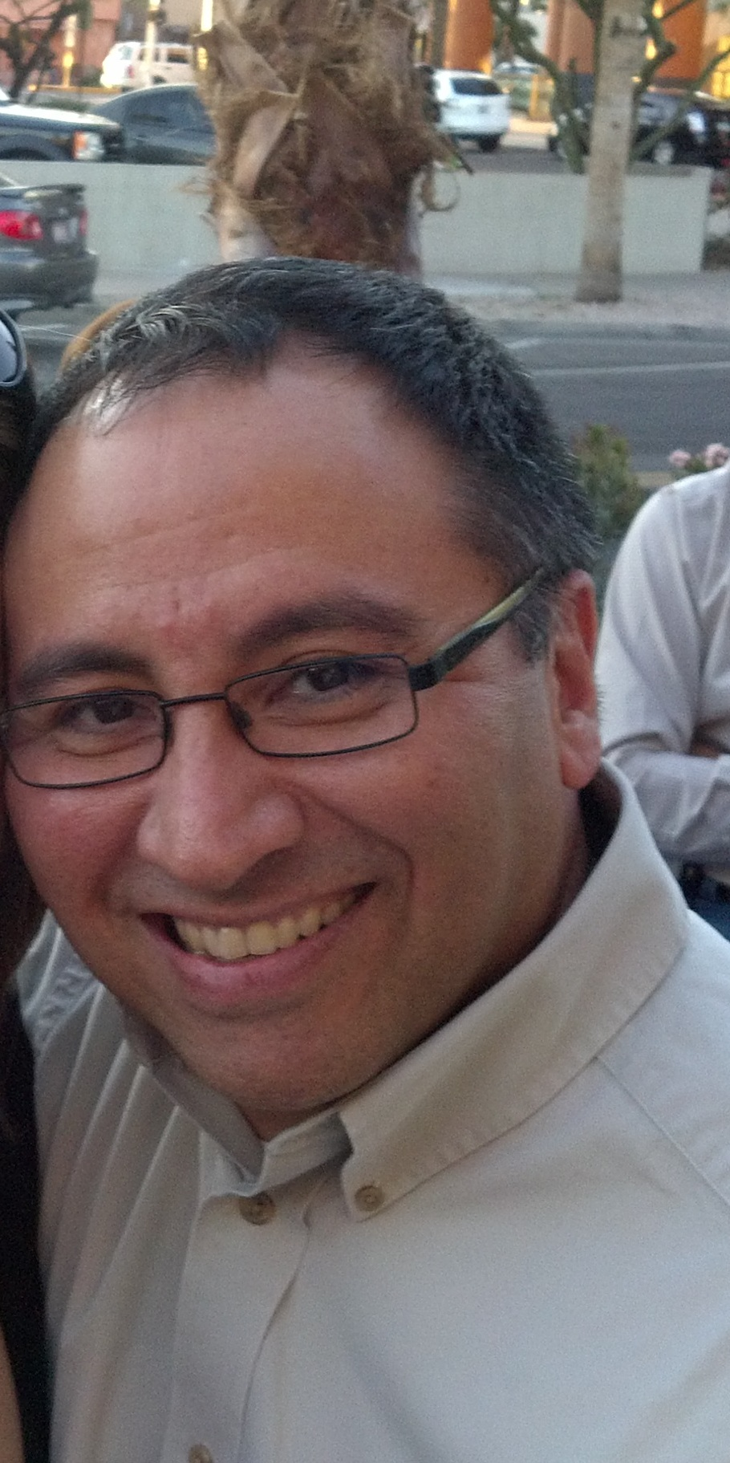

Carlo Sanchez, PHR
Senior EEO/AA Consultant
Arizona State University

Carlo Sanchez is the Senior EEO/AA Consultant at Arizona State University. Prior to his current role, he was the Affirmative Action Officer at Scottsdale Healthcare. Prior to that role, he was in Employee Relations and began his career with Scottsdale Healthcare in Benefits. His outreach activities include partnering with the City of Scottsdale to promote diversity objectives. His most recent accomplishments include the completion of two successful OFCCP audits.

Prior to joining Scottsdale Healthcare, Carlo has worked in various HR positions with companies in the technology sector.

Carlo graduated from Cornell University, receiving his Bachelor of Science degree from the School of Hotel Administration. He most recently received his PHR certification in January 2012.

