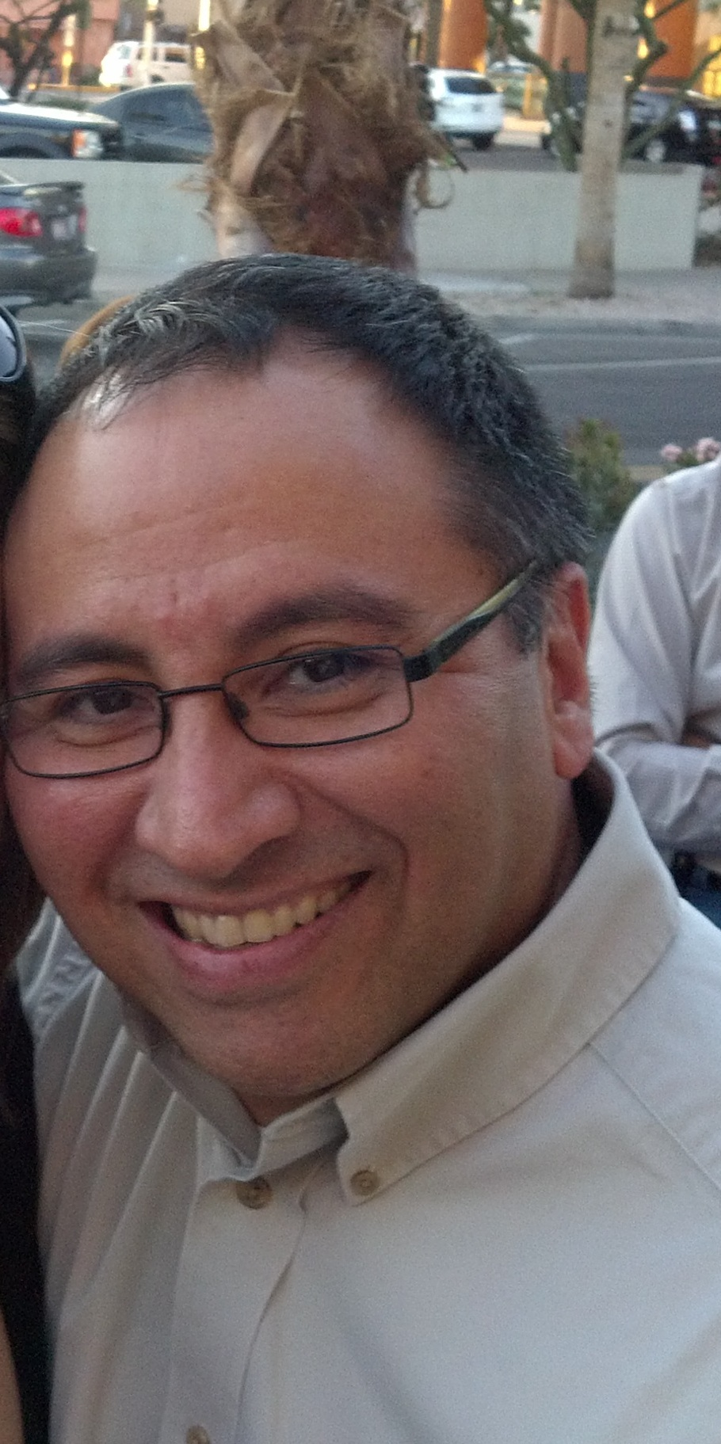

Carlo Sanchez, PHR
Sr. EEO Consultant
Arizona State University

Carlo Sanchez is the Sr. EEO Consultant for ASU. Within his role at ASU he is the ADA Coordinator and also administers the Affirmative Action Plan for ASU.

Prior to joining ASU, Carlo has worked at Scottsdale Healthcare and other HR positions with companies in the technology sector.

Carlo graduated from Cornell University, receiving his Bachelor of Science degree from the School of Hotel Administration. He most recently received his PHR certification in January 2012.

