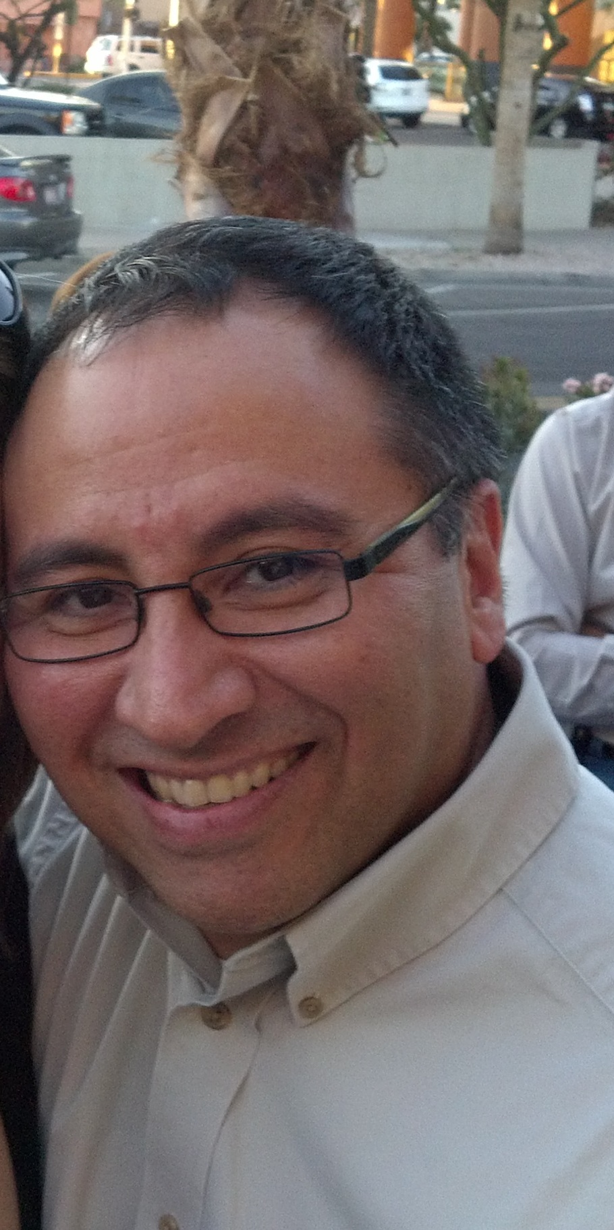

Carlo Sanchez, PHR
EEO/AAP Officer
Scottsdale Healthcare

Carlo Sanchez is the EEO/AAP Officer for Scottsdale Healthcare. Prior to his current role, he was in Employee Relations and began his career with Scottsdale Healthcare in Benefits. He currently also serves as a Diversity Ambassador and is responsible for administering the Emotional Intelligence Diversity Program company wide. His outreach activities include partnering with the City of Scottsdale to promote diversity objectives. His most recent accomplishments include the completion of two successful OFCCP audits.

Prior to joining Scottsdale Healthcare, Carlo has worked in various HR positions with companies in the technology sector.

Carlo graduated from Cornell University, receiving his Bachelor of Science degree from the School of Hotel Administration. He most recently received his PHR certification in January 2012.

